
Report Done by
Blinkit
Sales
Analysis
Using
Power
BI
Name: Fredolina Roselin S
Email: fredolina.roselin@gmail.com

Introduction to Power BI
Power BI is a powerful business intelligence and data visualization tool developed by Microsoft that enables organizations to transform raw data into meaningful and interactive insights. It supports data connection from multiple sources, data transformation using Power Query, data modeling, DAX-based calculations, and interactive visual storytelling through dashboards. Power BI allows users to analyze trends, compare performance metrics, and make data-driven decisions efficiently. Due to its flexibility and ease of use, Power BI is widely adopted in retail, finance, logistics, and e-commerce industries.

Business Problem Statement
The objective of this project is to conduct a comprehensive analysis of Blinkit’s retail sales performance, customer satisfaction, and inventory distribution. The analysis focuses on identifying key sales drivers, outlet performance, product category contribution, and customer preferences using well-defined KPIs and interactive visualizations in Power BI. The insights derived from this analysis help in understanding business performance and identifying opportunities for optimization.

Dataset Overview
The dataset used in this project was sourced from Kaggle and represents Blinkit-style retail sales data. It contains detailed transactional and outlet-level information including item attributes, outlet characteristics, sales values, customer ratings, and visibility scores. Key fields in the dataset include Item Type, Item Fat Content, Item Visibility, Outlet Size, Outlet Location Type, Outlet Type, Outlet Establishment Year, Total Sales, and Rating. This dataset enables multidimensional analysis across products, outlets, and locations.

Data Cleaning and Preparation
Data cleaning was performed to ensure accuracy and consistency before analysis. One major issue identified was inconsistency in the Item_Fat_Content column, where values such as LF, low fat, and reg represented the same categories. These inconsistencies were standardized using SQL queries by converting all variations into two uniform categories: Low Fat and Regular. This step was critical to avoid incorrect aggregations and ensure reliable analysis across visuals and KPIs. After cleaning, distinct values were verified to confirm successful standardization.

Key Performance Indicators (KPIs)
The dashboard includes four primary KPIs that provide a high-level overview of business performance. Total Sales represents the overall revenue generated and is approximately 1 million. Average Sales shows the average revenue per item sold, indicating consistent pricing and demand. Number of Items reflects the total count of items sold across all outlets, showing wide inventory movement. Average Rating, which is around 4, indicates stable customer satisfaction across products and outlets.

Dashboard Design and Features
The Power BI dashboard is designed to be fully interactive and user-friendly. A filter panel allows users to dynamically analyze data based on outlet location type, outlet size, and item type. KPI cards provide quick insights, while multiple charts such as line charts, donut charts, bar charts, and tables present detailed breakdowns. The layout ensures logical flow from summary metrics to granular insights.
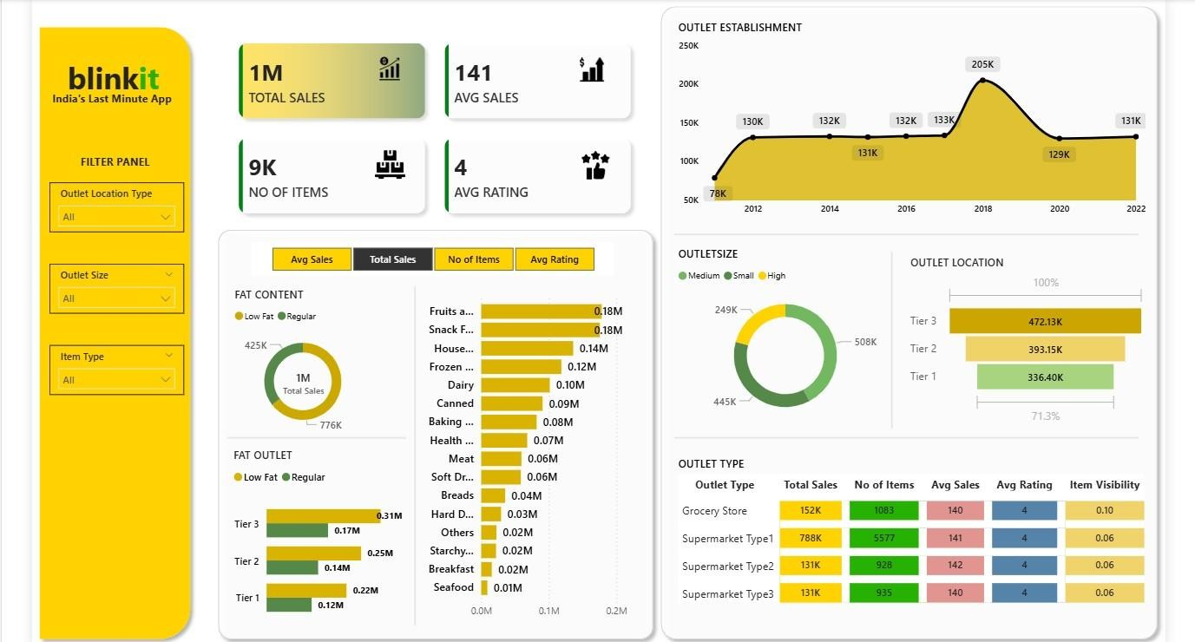

Analysis Performed
- Sales Analysis by Fat Content
The analysis compares total sales between Low Fat and Regular products. Regular fat items contribute slightly higher sales, indicating stronger customer preference toward regular products. Additional KPIs such as average sales and ratings remain relatively consistent across fat categories.
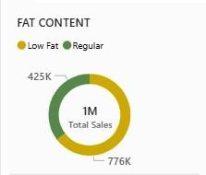
- Sales Analysis by Item Type
Item type analysis shows that categories such as fruits, snacks, and household items generate the highest revenue. These categories form the backbone of Blinkit’s sales performance. In contrast, seafood and breakfast items contribute the least, indicating lower demand or limited availability.
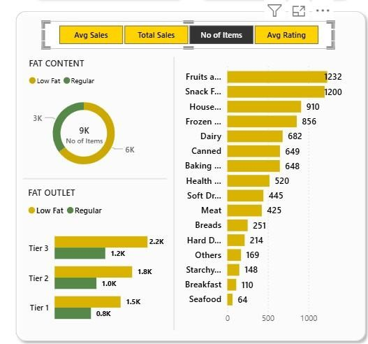
- Fat Content Sales by Outlet Location
A comparative analysis across outlet location types reveals that Tier 3 outlets generate higher sales for both Low Fat and Regular products. This indicates strong market penetration and demand in semi-urban regions.
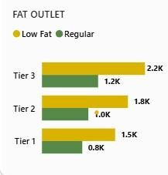
- Outlet Establishment Year Analysis
Sales trends based on outlet establishment year show steady growth over time, with peak performance observed around newer outlets. This suggests improved infrastructure, better supply chain management, and evolving consumer demand.
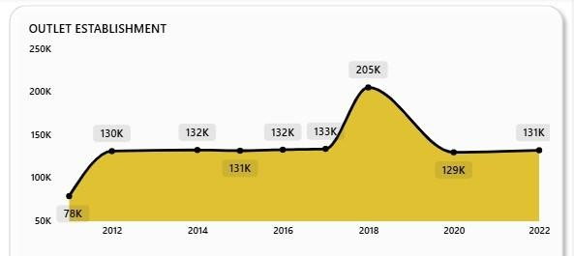
- Outlet Size Contribution
Medium-sized outlets contribute the highest percentage of total sales, followed by small and large outlets. This indicates that medium outlets strike the right balance between inventory availability and operational efficiency.
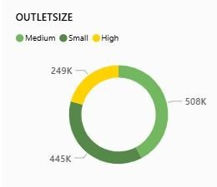
- Sales by Outlet Location
Among the three location tiers, Tier 3 locations outperform Tier 1 and Tier 2 in total sales, highlighting significant growth opportunities beyond metropolitan areas.
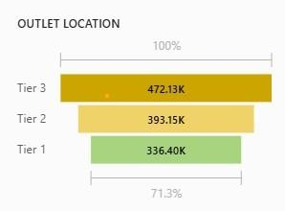
- Outlet Type Performance
Supermarket Type 1 dominates in total sales and number of items sold, making it the most profitable outlet format. Grocery stores generate lower sales but maintain stable ratings. Average ratings remain consistent across all outlet types, indicating uniform customer experience.
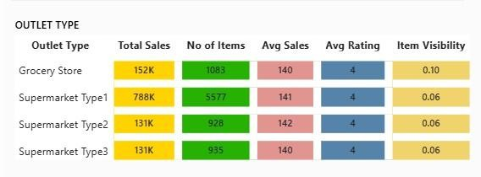
- Key Insights and Findings
The analysis reveals that Blinkit’s overall sales performance is strong, with consistent customer satisfaction across outlets. Product categories like fruits, snacks, and household items are key revenue drivers. Regular fat products outperform low-fat products in sales. Tier 3 locations and medium-sized outlets contribute the highest revenue, indicating untapped growth potential in non-metro areas. Supermarket Type 1 outlets emerge as the most successful outlet format in terms of both sales volume and item count.
- Final Learning Outcomes
This project enhanced my practical understanding of data cleaning, SQL-based data preparation, KPI creation, and interactive dashboard development using Power BI. I gained experience in translating business requirements into analytical visuals and learned how to derive meaningful insights from raw retail data. The project also improved my ability to communicate insights effectively through dashboards and reports, which is essential for datadriven decision-making.
- Conclusion
The Blinkit Sales Analysis dashboard successfully converts raw retail data into actionable insights using Power BI. The interactive visuals and KPIs provide a comprehensive view of sales performance, customer preferences, and outlet efficiency. This project demonstrates how business intelligence tools can support strategic planning and operational optimization in the retail sector. Overall, the analysis highlights growth opportunities, strengthens understanding of customer behavior, and showcases the effectiveness of Power BI as a decision-support system.

